In this lesson we are going to make our camera follow along the ball
So before adding script to the camera first make a simple demo level(It means that small scaled duplicated platform get added one after other to form a path and they are attached to our big platform ) so that we can actually test when the ball goes and how camera follow the ball when it goes throught her path formed
So I am going to create a very few platforms later on we can generate them randomly
but for now just create them to test the level
so duplicate our platformStart and rename it to platform because they are going to then scale down such that x is 2 and z is 2
If you drag something while also pressing ctrl then it move cm by cm
So we drag the small scaled plartform to reposition it like below
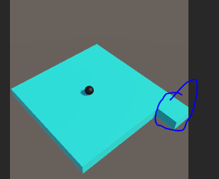
The marked one is the small scaled platform
So each time a new small scaled platform spawn in the front or right (x or z direction)of the previously spawned platform
Lets create few more platform and position them such that it look like below

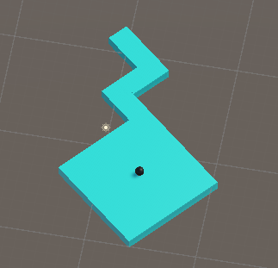
So now we will select the camera and now add aa script to it and name the script CameraFollow
and then open it in Visual Studio

first we are going to create a public variable of type GameObject and name it ball
we will assign it the gameObject(IOA) that we wnat to follow
So we wnat that the caera to follow the ball so we will assign the ball IOA to the ball variabale in teh script in IOA in Unity editor
We will create a varibale of type Vector3 named offset
Thiss offsset will be the distance between teh caamera and the ball
So now we will substract the position of the camera from the ball and give it to offset in start method as shown below
void Start()
{
offset = ball.transform.position - transform.position;
}
By this way we have the distance between in terms of x,y and z axis
and we want that distance should alwas be the same so that camera always follow the ball and the ditance remains the same
what we will do is resetting the offset(maybe the variable) of camera in our update method (I think here it means adding offset x ,y and z to the current x,y and z coordinate of camera to get final position that is x,y and z coordinate of the camera ) but if we do this then the camera may shake while moving(I don't know i think the camera will changes its position abruptly becaause of change in position of the ball very fast in going from one frame to next frame but the camrea chanhge in its position is based on call of update which is frame by frame ) but now to make it move smoothly
follow the ball
For this We declare a float varible lerpRate This is the rate by which the camera will change its position to follow the ball
we create a method and named it as Follow and of type void
Now we willl create another variable and call it Follow method
When the teacher say that you can never change the value of transform.position i think it means that you can never modify the object whose reference is stored in the transform.position for example we cannot do transform.position.x or tranform.position.y but you can reinitialize the transform.position with the reference of another Vector3 object (who knows)
We declare a variable of type Vector3 named pos and then give it the value of transform.position(means the current position of the camera as the script is attaced ot camera )
And now we can say that we eant to lerp(i think smooth transition) current value to the target value with thelerp rate
So what we are going to do is We call a static method of Vector3 that is Lerp
What this function does is it moves on from one value to another value with the rate thaat we will give it in his argument in ourcae we give it the rate stored in lerpRate variable ( I think it means transition from one value to other value frame by frame and each frame there will be constant increase( i think lerprate we pass to the Lerp static method ) in the previous value until it reaches the target value and while it changes value then it do it increamently between the frames to have smooth transition between the value of the consecutive frames

Nw befor Lerp method we decalare a variable of type Vector3 and name it targetPos this is the position that we want to acheive
that is Vector3 transPos = ball.transform.position – offset
Now in lerp method first argument tell us the initial position that is pos variable and the second parameter tell us the destination position that we want to reach and in third parameter we tell the rate by which the distance is travelled in each frame smoothly
we set the rate as lerpRate * Vector3.deltaTime

Vector3.deltatime helps to run the camera same in every machine independent of its frame rate
Means by this it speed will be same in all machines
The pos variable will be intialised with the position returned by Lerp method
and thne we give this pos varible to transform.position

Now we make boolean variable gameOver and then set it to false in start method and then in update method mnake a condition that if the gameOver is not true thtn the follow method will be called and if the gameOver is set to true then follow method will be called
Now drag and drop the ball IOA in the heirarchy panel to the the ball field in the CameraFollow script so our sript can access the ball in its logic

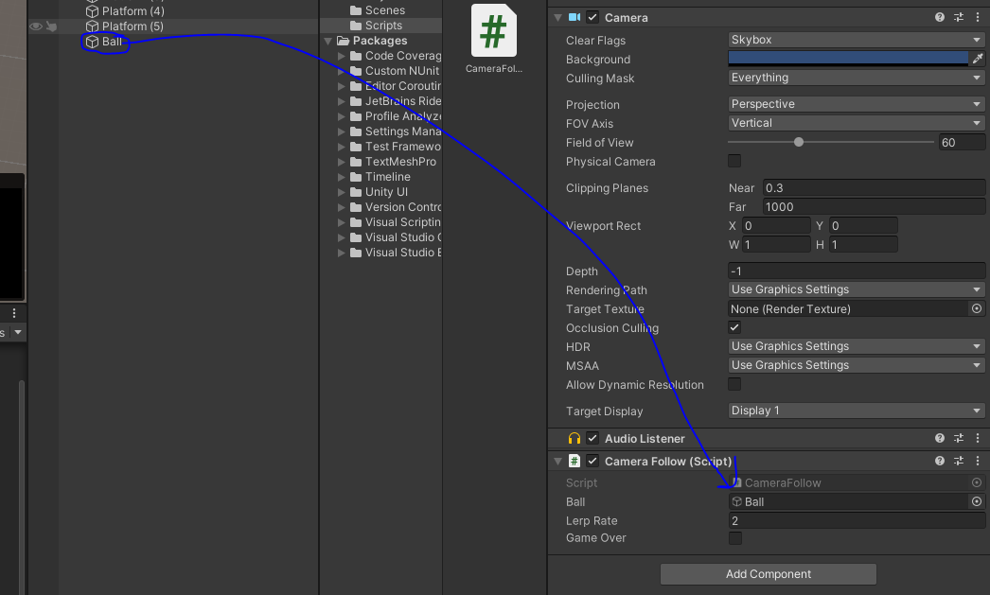
If we don't get the ball then we cannot get its position
Foe the lerprate we make it two
Now our code will look like below
using System.Collections;
using System.Collections.Generic;
using UnityEditor.AnimatedValues;
using UnityEngine;

public class CameraFollow : MonoBehaviour
{
public GameObject ball;
Vector3 offset;
// Start is called before the first frame update
public float lerpRate;
public bool gameOver;
void Start()
{
offset = ball.transform.position - transform.position;
gameOver = false;
}

// Update is called once per frame
void Update()
{
if (!gameOver)
{
Follow();
}
}
void Follow()
{
Vector3 pos = transform.position;
Vector3 transPos = ball.transform.position - offset;
pos=Vector3.Lerp(pos, transPos, lerpRate * Time.deltaTime);
transform.position = pos;
}
}

Now it follows the ball but if it falls down it is still following it so we don't want it to happen
Whenever the ball falls down nd GameOver happens we don't want the camera to follow the ball

Now in our ballController script
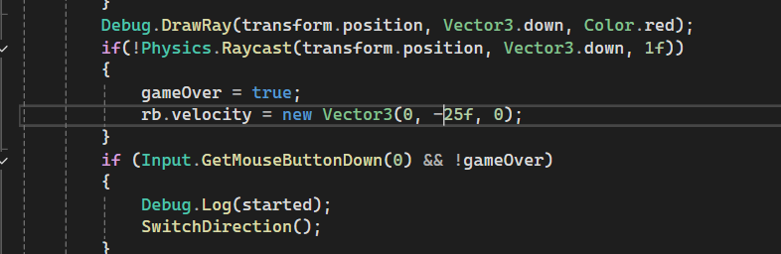
you can see above logic that whenever the ball crosses the platform then then its velocity go to y in downward direction due to which it falls down and we set gameOver to true
Now with the help of class member Camera.main we access the main camera in our scene panel or Heirarchy panel
and then through the reference inside it we call GetComponent<CameraFollow>()
By this we can access all the public method or variable of the script CameraFollow which is attached to our main Camera IOA (By this method we can access any script attached to an IOA by typing the name of the script between angular brackets ) and now through GetComponent<CameraFollow>() we will access the public variable gameOver ans set it to true do that our camera stop following it
So now our ballController update will look like below
void Update()
{
if(!started)
{
if (Input.GetMouseButtonDown(0))
{
rb.velocity = new Vector3(speed, 0, 0);
started = true;
}
}
Debug.DrawRay(transform.position, Vector3.down, Color.red);
if(! Physics.Raycast(transform.position, Vector3.down, 1f ) )
{
gameOver = true;
rb.velocity = new Vector3(0, -25f, 0);
Camera.main.GetComponent<CameraFollow>().gameOver = true;
}
if (Input.GetMouseButtonDown(0) && !gameOver)
{
Debug.Log(started);
SwitchDirection();
}
}

so in ballContoller script we are indirectly reinitilising the gameOver variable in CameraFollowscript so that the camera does not follow the ball when it got drop down from the platform since the gameOver is true now

Now in next lesson we will try to create platform randomly

